Tutorial 3 – Collectables

In this tutorial I will demonstrate how to create a collectable that can be picked up by the player and will be tracked using a UI text asset.

1. Start by creating a Sphere in the scene by right clicking in the hierarchy then going to 3D object and then sphere. Reposition the sphere to another section of the plane away from the character then rename the sphere in the inspector to Collectable. On the Sphere collider component tick the box that says Is Trigger

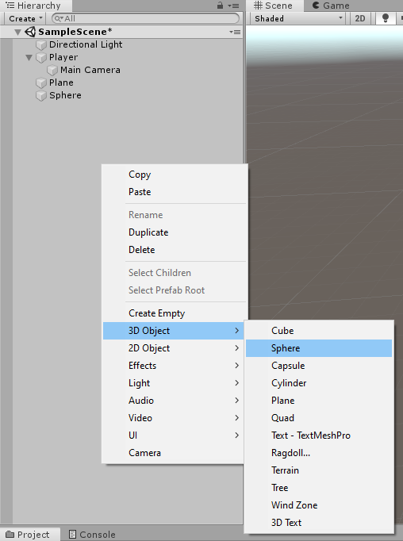

1. In the collectable’s inspector click on the tag dropdown menu and then click add tag. Click the plus symbol to add a new tag and name it Collectable. Reselect the collectable again and in the tag dropdown menu set its tag to Collectable.

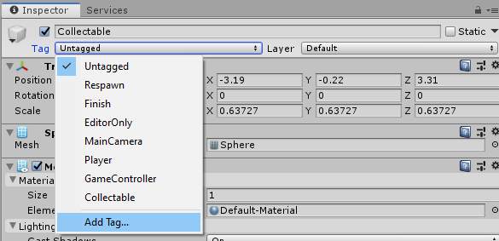 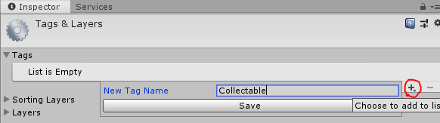

1. In the PlayerController script we made in the previous two tutorials we will make a new float called score which will track how many collectables you have picked up.



1. Next, we will make a ontriggerenter void this will track when the player collides with a trigger collider. In this void we will use an if statement that will check that the collisions object tag is “Collectable” if so, it will add +1 to the score and then delete the collectable.

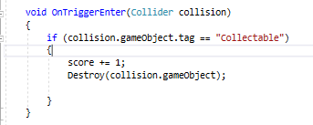

1. Finally we will create a UI element that displays your score. To do this we need to first go into the hierarchy, right click and then go into UI to create a text element. Then Rename the text to Score in the inspector.

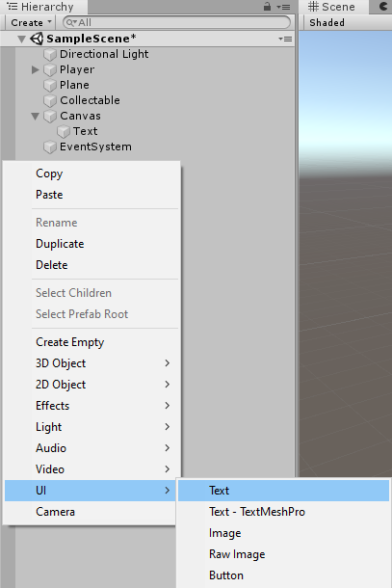

1. Back in the PlayerController script go to the very top and below where it says using UnityEngine we will add a line of code saying using UnityEngine.UI, this will allow us to change the UI score text.

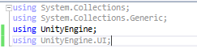

1. Now we will reference the text element in the code and name it txt so we don’t get confused.

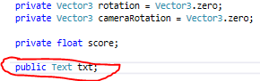

1. Next, we have the text element referenced we can add the score to it by making score a string and then setting the UI text to be equal to it within the update void
2. 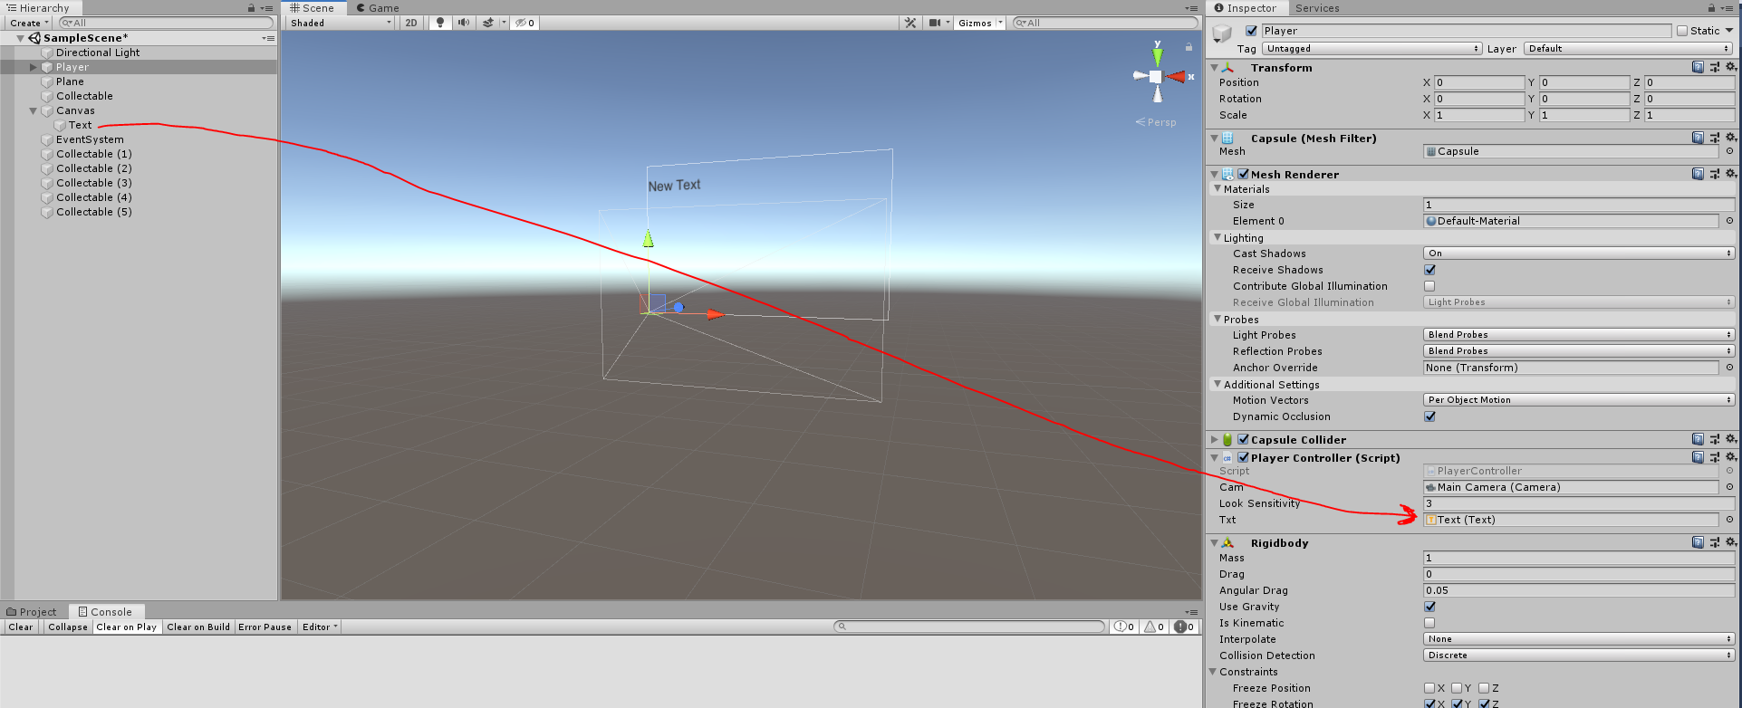We can now go to the player object in the inspector and drag the UI text element into the txt box.
3. Finally reposition the UI element to whereever you please using the w key(prefereably out of the centre of the UI canvas. You may also want to duplicate the collectable a few times using ctrl + D while having the collectable selected so you can track multiple collectables.